What’s the Buzz?

One-day PROFESSIONAL WTB TRAINING
with Mark Le Messurier and Noni Le Messurier
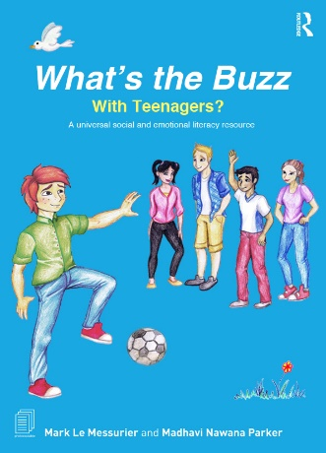
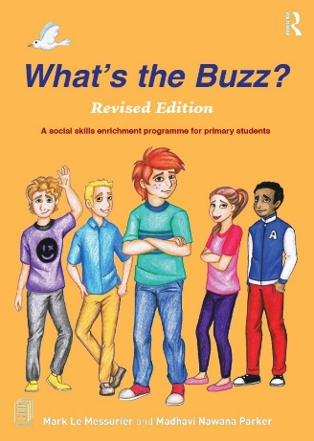
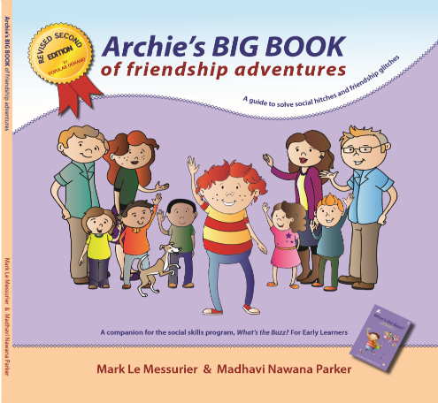
at St Francis Winery Resort, Old Reynella (face to face) or via ZOOM (online)

Training Day opportunities available in 2021:
Friday 12th March, 9am to 3pm (Term 1, face to face)
Friday 23rd April, 9am to 3pm (school holidays, face to face)
Saturday 5th June, 9am to 3pm (Term 2, ZOOM)
Friday 16th July, 9am to 3pm (school holidays, face to face)
Friday 3rd September, 9am to 3pm (Term 3, face to face)
Monday 13th December, 9am to 3pm (school holidays, ZOOM)

PD Certificates, PowerPoints and comprehensive notes issued on completion

What's the Buzz? is a complete social and emotional literacy approach comprised of 48 lessons and guided conversations over 3 programs;
What's the Buzz? for EARLY LEARNERS - 16 lessons - (ages 5 to 8 years)
What's the Buzz? for PRIMARY STUDENTS - 16 lessons - (ages 9 to 11 years)
What's the Buzz? with TEENAGERS - 16 lessons - (ages 12 to 15 years)
This evidence-based program is now in more than 130 countries. It teaches young people social and emotional intelligence and is complimented by a deep selection of online resources. The program has also become a required text for teachers, counsellors, psychologists, social work and youth workers in training at many Universities worldwide.
There are two broad approaches at our disposal to teach Social and Emotional literacy (SEL) and we shall explore these;
- Specific SEL programs
What's the Buzz? and how to present all 3 programs is the main focus.
- Guided social interactions; a planned, relaxed and purposeful way to expand SEL will be explored in the morning
A ‘guided social interaction’ is where individuals are arranged to be with each other, to enjoy one another and learn the BIG 8 SEL capabilities. ‘Guided social interactions’ are a captivating way to initiate and build SEL between people of all ages.
For more information, visit www.whatsthebuzz.net.au

REGISTRATION - complete the form on the following page and return the Word doc. to Elissa via email at registrations@marklemessurier.com.au

What’s the Buzz?
ABN: 19 642 144 750
69 Goodwood Road
Wayville SA 5034
P: 0411 343 574
E: registrations@marklemessurier.com.au
W: www.whatsthebuzz.net.au

REGISTRATION FORM
One-day PROFESSIONAL WTB TRAINING
with Mark Le Messurier and Noni Le Messurier
at St Francis Winery Resort, Old Reynella (face to face) or via ZOOM (online)
PERSONAL DETAILS
First Name
Surname
School/Business Name
Postal Address
Phone | Work |  | Mobile
Email | Work
Email | Personal
INVOICE/FINANCE OFFICER DETAILS
Finance Officer Name
School/Business Name
Postal Address
Finance Officer Email

Please provide both personal and work email to ensure you receive all correspondence. We’ve learnt from experience that some school severs will block emails with attachments.
Nominate ONE Training Day date (delete dates not wanted):
Friday 12th March, 9am to 3pm (Term 1, face to face)
Friday 23rd April, 9am to 3pm (school holidays, face to face)
Saturday 5th June, 9am to 3pm (Term 2, ZOOM)
Friday 16th July, 9am to 3pm (school holidays, face to face)
Friday 3rd September, 9am to 3pm (Term 3, face to face)
Monday 13th December, 9am to 3pm (school holidays, ZOOM)
Total Cost (face to face): $350 per person (incl. GST) *group discounts available
Total Cost (ZOOM): $300 per person (incl. GST) *group discounts available
Please return this form via email to Elissa at registrations@marklemessurier.com.au who will confirm your registration and issue an invoice. Once payment is received, Elissa will email the pre-reading and support information for the event, as well as a detailed overview of the Training Day.

Conditions and Cancellation Policy
Invoice MUST BE settled ONE WEEK before the Training Day, otherwise participation will not occur.
Cancellation 6 days prior to event – 25% cost retained. Cancelation less than 4 days prior to event – 50% cost retained.
Cancelation less than 48 hours prior to event – Non-refundable.

